**Student Grade Entry**

**Steps:**

1. 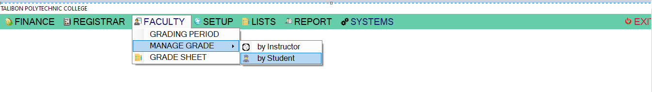Under submodules “**MANAGE GRADE**”,Click function “**by Student**”
2. 1-Dropdown Course/Level

2-Dropdwon Batch

3-Click Search Button

There are two types to filter name of a student

4-Search box

5-Listview Filter

6.Double click Student Name on the list to view the “**STUDENT GRADING LIST**”

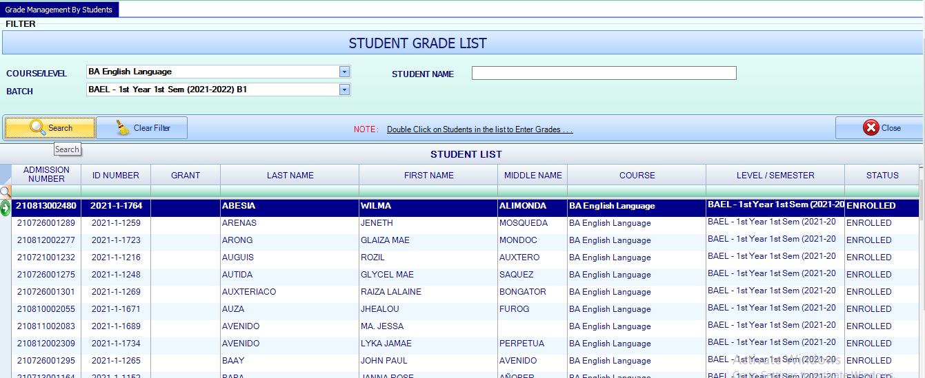

2

6

5

4

3

1

1. 7-Double click Subject on the list to view the “**GRADING ENTRY”**

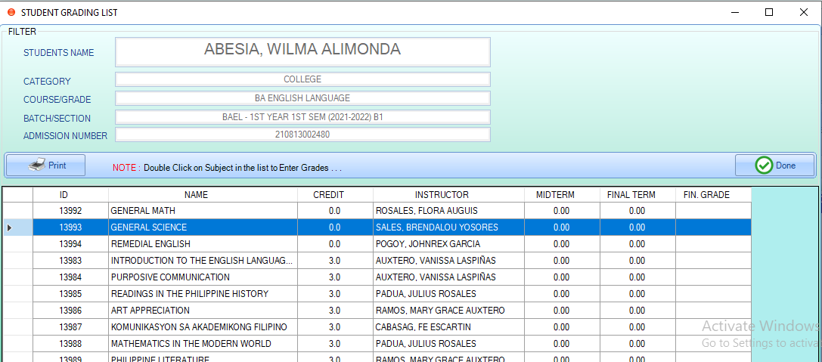

7

1. Two types of “**GRADING ENTRY**” 8.1 Single Entry and 8.2 Multiple Entry

8.1 Dropdown Gradeing Period

8.1-9 Input desired grades on Grade textbox

8.1-10 Input remarks on Remarks textbox

8.1-11 Input desired grades on Final Grade textbox

8.1-12 Click “Apply Grades” button to add grades on the list

8.1-13 Click “**Set as Final Grade**” button

8.1-14 Click “**Done**” to close the form 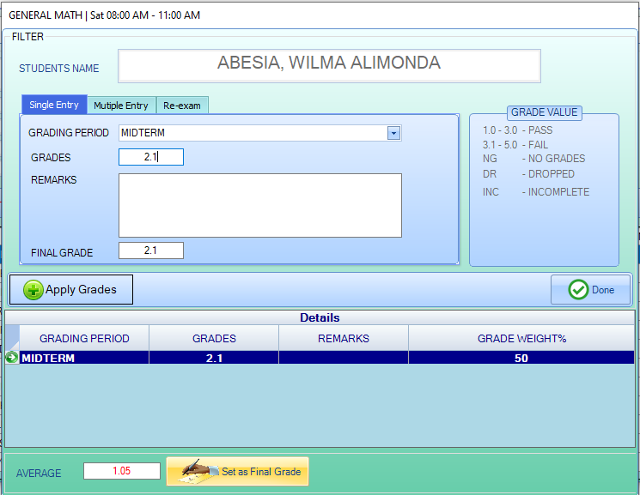

89

9

1400

1300

1200

1100

1000

8.2 The Gradeing Period is on the Category column

8.2-9 Click Grade column on the list to input a desired grade

8.2-10 Click Remarks column on the list to input a remarks

8.2-11 Click Final Grade column on the list to input a desired grade

8.2-12 Click “Apply Grades” button to add grades on the list

8.2-13 Click “**Set as Final Grade**” button

8.2-14 Click “**Done**” to close the form

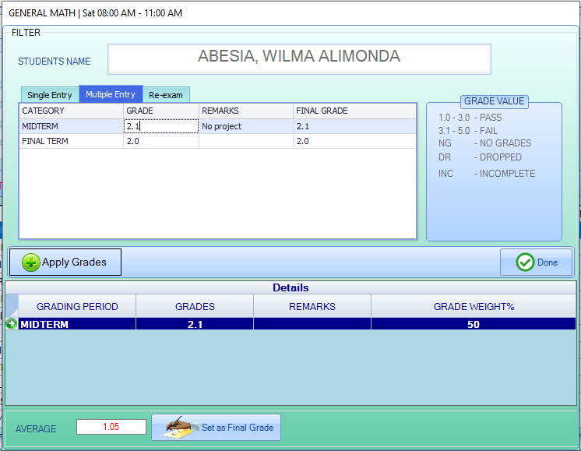

1300

1400

1200

1100

1000

9

8

1. When your are done inputing all the grades of the student

15-Click “**Print**”

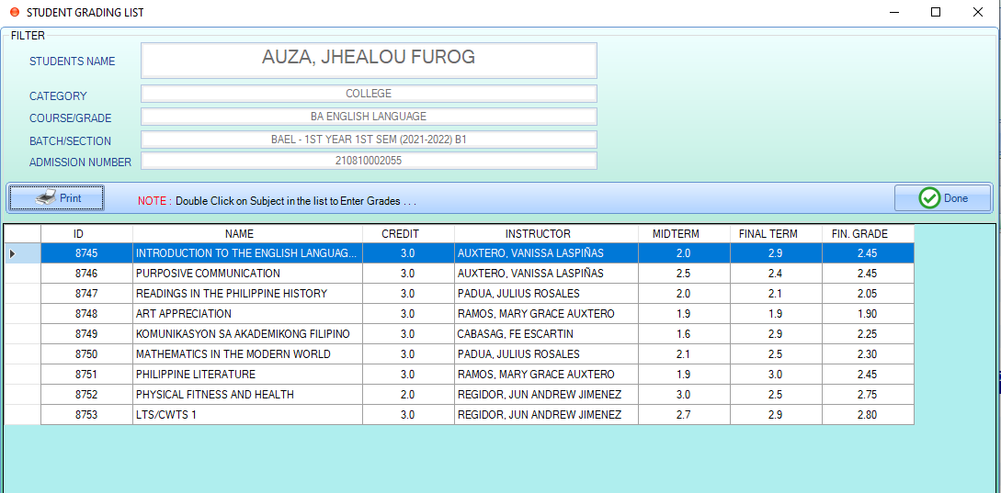

1500

